# Question 1

****（a）****

**i.**

The statement is correct.

$$({49)}_{10}=3*{16}^{1}+1*{16}^{0}={\left(31\right)}_{16}$$

$${(49)}_{10}=2^{5}+2^{4}+2^{0}={(110001)}_{2}$$

**ii.**

The statement is correct.

$${(7B)}_{16}=7*{16}^{1}+11={(123)}_{10}$$

$${(123)}_{10}=2^{6}+2^{5}+2^{4}+2^{3}+2^{1}+2^{0}={(1111011)}_{2}$$

**(b)**

$${(1101.0111)}_{2}=2^{3}+2^{2}+2^{0}+2^{-2}+2^{-3}+2^{-4}={(13\frac{7}{16})}_{10}$$

**(c)**

$${(61453)}_{10}=15*{16}^{3}+13={(F00D)}_{16}$$

**(d)**

$${abc.de}_{x}=a*x^{2}+b*x^{1}+c+d*x^{-1}+e*x^{-2}=ax^{2}+bx+c+\frac{d}{x}+\frac{e}{x^{2}}$$

**(e)**

$${(13)}_{x}+{(82)}_{x}=x^{1}+3+8*x^{1}+2=9x+5$$

So we know:

$$9x+5=17$$

Thus:

$$x=\frac{4}{3}$$

# Question 2

**（a）**

**Base Case:**

When n=1, $n^{3}+2n$ =3, which is divisible by 3.

**Inductive Hypothesis:**

Assume the statement holds for an positive number k, $n^{3}+2n$ is always divisible by 3.

**Inductive Step:**

$${(k+1)}^{3}+2\left(k+1\right)=k^{3}+3*k^{2}+3*k+1+2*k+2=\left(k^{3}+2k\right)+3*(k^{2}+k+1)$$

We know that $k^{3}+2k$ is divisible by 3, and $3*(k^{2}+k+1)$ is obviously divisible by 3 too.

So, we can tell that for any positive number, $n^{3}+2n$ is divisible by 3.

**(b)**

**i.**

Newly infected persons are $2^{n}$ after n rounds of infection, and it’s a geometric sequence with a ratio of 2.

**ii.**

$$S_{n}=2^{0}+2^{1}+…+2^{n-1}+2^{n}=\frac{1-2^{n+1}}{1-2}=2^{n+1}-1$$

The total number of infected persons after $n$ rounds of infection is $2^{n+1}-1$

**iii.**

$$S_{5}=2^{6}-1=63$$

So, If we let the disease spread at the same rate, $63$ persons will be infected after 5 rounds

**(c)**

$$\lim_{n→∞}{\frac{1}{n(n+1)}=}\lim_{n→∞}{\frac{1}{n}-\frac{1}{n+1}=0}$$

So the sequence is convergent.

Let the sum of the series equal to $s_{n}$, then:

$$S_{n}= \frac{1}{1*2}+\frac{1}{2*3}+…+\frac{1}{n*\left(n+1\right)}=\left(1-\frac{1}{2}\right)+\left(\frac{1}{2}-\frac{1}{3}\right)+…+\left(\frac{1}{n-1}-\frac{1}{n}\right)+\left(\frac{1}{n}-\frac{1}{n+1}\right)=1-\frac{1}{n+1}=\frac{n}{n+1}$$

**(d)**

We can use the formula for the sum of an arithmetic series:

$$S=\frac{n}{2}\left(a_{1}+a_{n}\right)$$

Where S is the sum, n is the number of terms, $a_{1}$ is the first item, $a_{n}$ is the fifth item.

We already know that $a_{1}$ is 5, $a_{n}$ is 1555. And:

$$n=\frac{a_{n}-a_{1}}{5}+1=311$$

So,

$$S=\frac{311}{2}*\left(5+1555\right)=242580$$

Thus, the sum of all positive integers, from 5 to 1555 inclusive, that are divisible by 5, is $242580$.

**(e)**

**a)**

For an arithmetic series, $a_{1}$ is 51, $a_{8}$ is 100, then the common difference is $\frac{100-51}{8-1}=7$

Then the regular expression of the nth item of the series is $51+7\left(n-1\right)=7n+44$

Thus, the twentieth term of the series is $7*20+44=184$

**b)**

According to the property of the arithmetic series, the sum of $a_{n}$ is

$$S_{n}=\frac{n}{2}*(a_{1}+a_{n})$$

So, we have

$$S_{20}=\frac{20}{2}*\left(51+184\right)=2350$$

So, the sum of the first twenty terms of the series is $2350$.

# Question3

**(a)**

the time 15 hours before 11 p.m. is $20$. Prove:

$$11\left(mod24\right)≡35\left(mod24\right)$$

$$35-15(mod24)≡20(mod24)$$

**(b)**

$$2^{81}={{(2}^{16})}^{5}*2$$

Due to Fermat’s Little Theorem,

$$2^{16}≡1(mod17)$$

Thus,

$$2^{81}≡1^{5}*2≡2(mod17)$$

Therefore, the remainder when $2^{81}$ is divided by 17 is $2$.

**(c)**

**i.**

$360=13*27+9$, So

$$360≡9(mod13)$$

And since 9 is smaller than 13, so $9$ is the smallest non-negative integer for 360 mod 13.

**ii.**

$-86+9*10 = 4$, So

$$-86≡4(mod10)$$

Since 4 is smaller than 10, $4$ the smallest non-negative integer for -86 mod 10.

**(d)**

$$3^{64}={{(3}^{66})}^{-2}$$

Due to Fermat’s Little Theorem,

$$3^{66}≡3^{-2}(mod67)$$

Due to Module Inverse,

$$3^{-2}≡9(mod67)$$

So, $3^{64}≡9(mod67)$

# Question 4

**(a)**

We know that

$$\tan{（A+B)}=\sqrt{3}，\tan{（A-B)}=\frac{1}{\sqrt{3}}$$

Due to tangent sum identity,

$\tan\left(A+B\right)=\frac{\tan{A}+\tan{B}}{1-\tan{A}\tan{B}}=\sqrt{3}$ ①

Due to tangent difference identity,

$\tan\left(A-B\right)=\frac{\tan{A}-\tan{B}}{1+\tan{A}\tan{B}}=\frac{1}{\sqrt{3}}$ ②

By ① and ②, We get:

$\tan{A}=1, \tan{B}=2-\sqrt{3}$ ③

We already know that:

$A+B≤\frac{π}{2}, A>B$ ④

We get:

$$A=\frac{π}{4}, B=\tan^{-1}{(2-\sqrt{3})}=0.2618$$

****(b)****

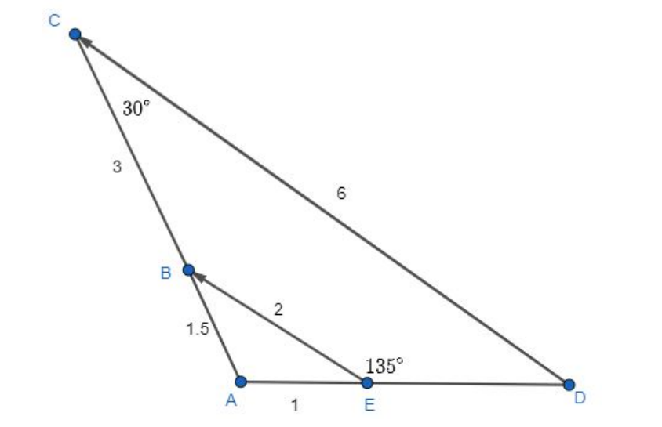

Due to property of similar triangles,

$$\frac{CD}{BE}=\frac{AD}{AE}$$

We get:

$$AD=3$$

Due to property of trigonometric geometry,

$$∠A=∠BED-∠ABE=∠BED-∠ACD=105°$$

**(c)**

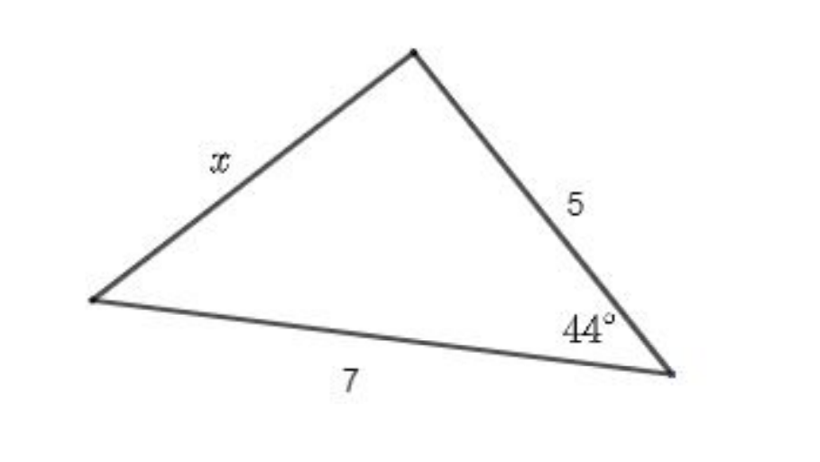

Due to the cosine theory,

$$x^{2}=5^{2}+7^{2}-2*5*7*\cos{44°}$$

Solve this equation, we get:

$$x=4.86$$

**(d)**

**Prove:**

Divide the numerator and denominator simultaneously by $\cos{θ}$, then apply $\tan{θ}=\frac{a}{b}$,

we get:

$$\frac{a\sin{θ}-b\cos{θ}}{a\sin{θ}+b\cos{θ}}=\frac{a\tan{θ}-b}{a\tan{θ}+b}=\frac{\frac{a^{2}}{b}-b}{\frac{a^{2}}{b}+b}=\frac{a^{2}-b^{2}}{a^{2}+b^{2}}$$

# Question 5

**(a)**

**i.**

The answer is **D**.

for A, The acceleration of the object must be zero, as there is no change in speed or direction.

For B, The direction of the object is not changing, as constant speed implies motion along a straight path.

For C, The velocity of the object is constant, as velocity involves both speed and direction.

**Therefore, all of the statements A, B, and C are true.**

**ii.**

The answer is **B**.

At the highest point of the ball's trajectory, its velocity $v$ is zero since it momentarily stops before reversing direction. However, the acceleration $a$ remains non-zero due to the gravitational force acting on the ball even at the highest point.

**iii.**

The answer is **A(45m in 3s).**

**Process:**

$$H=\frac{{v_{0}}^{2}}{2g}=\frac{{(30m/s)}^{2}}{2*10m/s^{2}}45(m)$$

$$T=\frac{v_{0}}{g}=\frac{30m/s}{10m/s^{2}}=3(s)$$

Therefore, the correct answer is: A. 45 m in 3 s

**(b)**

**i.**

$$f\left(x\right)=\frac{x-3}{x^{2}+9x-22}=\frac{x-3}{(x+11)(x-2)}$$

From the formula, we have:

$$(x+11)(x-2)≠0$$

We get from it that **the domain of the function is $\left(-∞, -11\right)∩\left(-11, 2\right)∩(2, +∞)$**

**ii.**

We have $\frac{x-3}{x^{2}+9x-22}=y$, it equals to $yx^{2}+\left(9y-1\right)x-\left(22y-3\right)=0$.

We know $∆=\sqrt{b^{2}-4ac}=\sqrt{169y^{2}-30y+1}≥0$

Therefore, $169y^{2}-30y+1≥0$,

We can get $y≥\frac{2\sqrt{14}+15}{169} and y≤\frac{-2\sqrt{14}+15}{169}$

So, the range of the function is

**iii.**

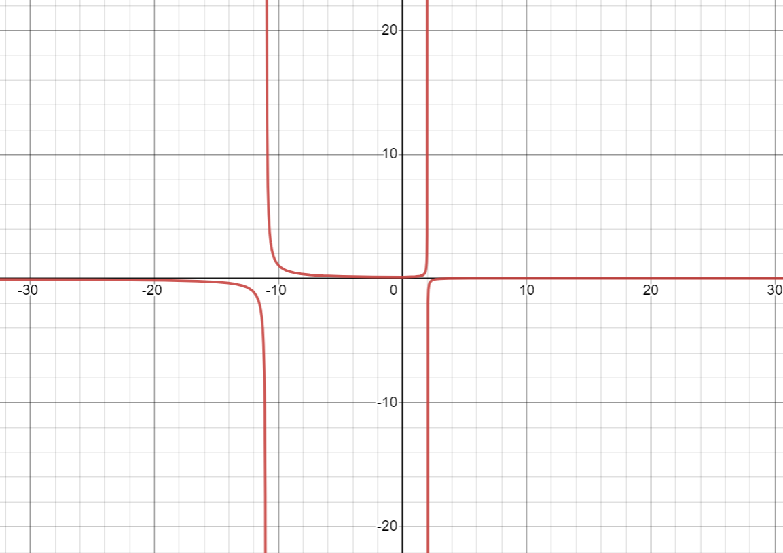

**(c)**

1. for onto.

For each y, there exists at least one matching x. So the function is onto.

2. for one-to-one.

Plot a line on the graph, as the orange one, it indicates that there exists different x with the same matching y, so the function is not onto.

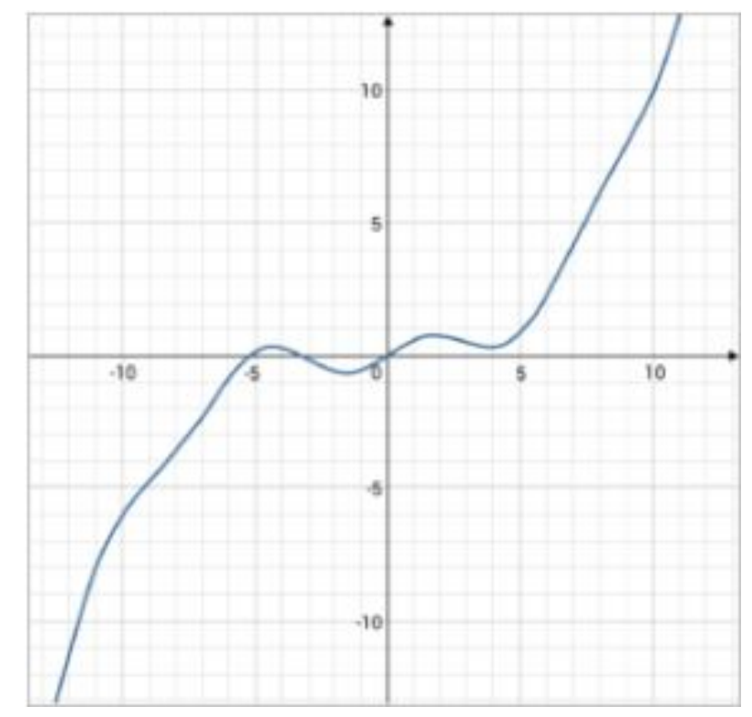

**(d)**

We can plot out the graph of the function.

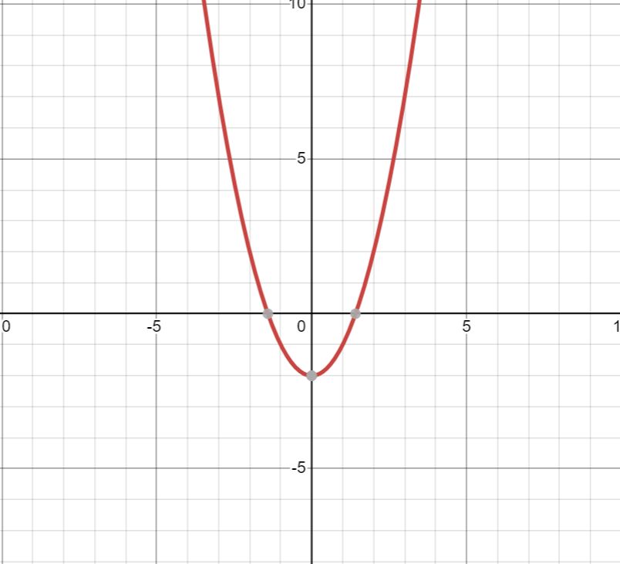

1. The function **is** **not one-to-one**, since for each $y$ in the range of the function and $y>0$, there exists $x=±\sqrt{y+2}$ matching it. It means there are some y having more than one matching $x$, so the function is not one-to-one.

2. The function **is onto**, because for each $y$ in the range of the function , there always exists at least one matching $x$.